**E-COMMERCE WEBSITE**

**DISCRETE STRUCTURES**

**PROJECT REPORT**

**Submitted by:**

**Naman Jain (2k19/IT/086)**

**Parth Dua (2k19/IT/095)**

**Submitted to:**

**Mrs. Swati Sharda**

**Asst. Prof.**



**DEPARTMENT OF INFORMATION TECHNOLOGY**

**DELHI TECHNOLOGICAL UNIVERSITY**

(Formerly Delhi College ofEngineering)

Bawana Road, Delhi-110042

**DEPARTMENT OF INFORMATION TECHNOLOGY**

**DELHI TECHNOLOGICAL UNIVERSITY**

**(Formerly Delhi College of Engineering)**

**Bawana Road, Delhi-110042**

**DECLARATION**

**CANDIDATE’S DECLARATION**

We, **NAMAN JAIN (Roll No. 2K19/IT/086)** and **PARTH DUA (Roll No. 2K19/IT/095)**, students of B.Tech. (INFORMATION TECHNOLOGY), hereby declare that the project Dissertation titled “**E-COMMERCE WEBSITE**” which is submitted by us to the Department of INFORMATION TECHNOLOGY, Delhi Technological University, Delhi in partial fulfillment of the requirement for the award of the 3rd semester of the Bachelor of Technology, is original and not copied from any source without proper citation. This work has not previously formed the basis for the award of any Degree, Diploma Associateship, Fellowship or other similar title or recognition.

Place: Delhi

Date: 1-12-2020

**Naman Jain**

**Parth Dua**

**DEPARTMENT OF INFORMATION TECHNOLOGY**

**DELHI TECHNOLOGICAL UNIVERSITY**

**(Formerly Delhi College of Engineering)**

**Bawana Road, Delhi-110042**

**CERTIFICATE**

This is to certify that **Naman Jain (2k19/IT/086)**

and**Parth Dua (2k19/IT/095)***,* the students of IT-B have successfully completed the **E-COMMERCE WEBSITE** project as the 3rd Semester Innovative project under the guidance of

**Mrs. Swati Sharda** during the year 2020-21.

**DEPARTMENT OF INFORMATION TECHNOLOGY**

**DELHI TECHNOLOGICAL UNIVERSITY**

**(Formerly Delhi College of Engineering)**

**Bawana Road, Delhi-110042**

**ACKNOWLEDGEMENT**

We would like to convey our heartfelt thanks to our supervisor **Mrs. Swati Sharda** for her ingenious ideas, tremendous help and cooperation. We are extremely grateful to our friends who gave valuable suggestions and guidance for completion of our project. The cooperation and healthy criticism came handy and useful with them.

**ABSTRACT**

**E-commerce** (**electronic commerce**) is the activity of electronically buying or selling of products on online services or over the Internet. Electronic commerce draws on technologies such as mobile commerce, electronic funds transfer, supply chain management, Internet marketing, online transaction processing, electronic data interchange (EDI), inventory management systems, and automated data collection systems.

Modern electronic commerce typically uses the World Wide Web for at least one part of the transaction's life cycle although it may also use other technologies such as e-mail. Typical e-commerce transactions include the purchase of online books (such as Amazon) and music purchases (music download in the form of digital distribution such as iTunes Store), and to a lesser extent, customized/personalized online liquor store inventory services. There are three areas of e-commerce: online retailing, electronic markets, and online auctions.

The objective of the website is to provide an interface to users to purchase items online and track their delivery.The website offers various options to the user , like user can scroll through different categories of the products and select “Quick View” to get the details of the product and can Add it to the cart for future references.

Users can also see the recommended items popping on the web pages depending on their search history.After selection of the products the user can BUY the products through their cart. On successfully adding the shipping details the user gets a tracking ID which he/she can use to track their order in future.

This option generates a beautiful graph of the path/route that will be followed for the delivery from the nearby source to the user’s destination.

There is also a Donation page where the user can donate any item and NGO’s near them will come to receive them

**INTRODUCTION**

⦁ **Introduction to HTML, CSS and Javascript:**

HyperText Markup Language (HTML), Cascading Style Sheets (CSS), and JavaScript are the languages that run the web. They’re very closely related, but they’re also designed for very specific tasks. Understanding how they interact is a key to become a good web developer. Simply stating :

⦁ HTML is for adding meaning to raw content by marking it up.

⦁ CSS is for formatting that marked up content.

⦁ JavaScript is for making that content and formatting interactive.

Think of HTML as the skeleton of a web page that contains abstract text and images behind the scenes, CSS as the page that actually gets displayed, and JavaScript as the behaviors that can manipulate both HTML and CSS. All 3 of them are totally different languages, but they all refer to one another in some way. Most websites rely on all three to make them user friendly and visually appealing.

**⦁ Introduction to Bootstrap:**

Bootstrap is a free and open-source tool collection for creating responsive websites and web applications. It is the most popular HTML, CSS, and JavaScript framework for developing responsive, mobile-first web sites. It solves many problems, one of which is the cross-browser compatibility issue. Nowadays, the websites are perfect for all the browsers (IE, Firefox and Chrome) and for all sizes of screens (Desktop, Tablets, Phablets, and Phones). All thanks to Bootstrap developers -Mark Otto and Jacob Thornton of Twitter, though it was later declared to be an open-source project.

Why Bootstrap?

⦁ Faster and Easier Web-Development.

⦁ It creates Platform-independent web-pages.

⦁ It creates Responsive Web-pages.

⦁ It is designed to be responsive to mobile devices too.

⦁ It is Free! Available on www.getbootstrap.com

⦁ **Introduction to Python Programming Language:**

Python is a widely used general-purpose, high level programming language. It was created by Guido van Rossum in 1991 and further developed by the Python Software Foundation. It was designed with an emphasis on code readability, and its syntax allows programmers to express their concepts in fewer lines of code. Python is a programming language that lets us work quickly and integrate systems more efficiently.

There are two major Python versions: Python 2 and Python 3. Both are quite different.

Interesting fact: Python is named after the comedy television show Monty Python’s Flying Circus. It is not named after the Python snake.

**⦁ Introduction to Django:**

Django was initially developed between 2003 and 2005 by a web team who were responsible for creating and maintaining newspaper websites. After creating a number of sites, the team began to factor out and reuse lots of common code and design patterns. This common code evolved into a generic web development framework, which was open-sourced as the "Django" project in July 2005.

Django is a high-level Python web framework that enables rapid development of secure and maintainable websites. Built by experienced developers, Django takes care of much of the hassle of web development, so we can focus on writing our app without needing to reinvent the wheel. It is free and open source, has a thriving and active community, great documentation, and any options for free and paid-for support. Django helps us write software that is Complete, Versatile, Secure, Scalable, Maintainable and Portable.

⦁ Introduction to SQLite:

SQLite is a relational database management system (RDBMS) contained in a C library. In contrast to many other database management systems, SQLite is not a client–server database engine. Rather, it is embedded into the end program.

SQLite is a self-contained, high-reliability, embedded, full-featured, public-domain, SQL database engine. It is the most used database engine in the world. It is an in-process library and its code is publicly available. It is free for use for any purpose, commercial or private. It is basically an embedded SQL database engine. Ordinary disk files can be easily read and write by SQLite because it does not have any separate server like SQL. The SQLite database file format is cross-platform so that anyone can easily copy a database between 32-bit and 64-bit systems. Due to all these features, it is a popular choice as an Application File Format.

**METHODOLOGY**

**FRONTEND:-**

**⦁ HTML/CSS/BOOTSTRAP :-**

We have around 11 pages on our website.

To create the structure of the website we used HTML.

To design the website we use CSS.

To implement the sliding property on the website we are using bootstrap features and BOOTSTRAP is also used to implement the form functionality on pages as well.

**⦁ JAVASCRIPT:-**

To add the functionalities to our webpage of user interaction we have used JavaScript.

We have implemented a recommendation system in our website in which , whenever the user “quick views” any item the frequency of viewing that item increases and we are using max heap to find the top 3 viewed items on the basis of their frequency to implement it.

The max heap we have used is implemented from scratch using JavaScript.

We have implemented a tracker system in our website which takes input the user email and order id for validation purposes and it shows the shortest path that will be taken by the delivering company to deliver the product to the user's destination from the main center nearby.

For finding the minimum distance we have implemented dijkstra’s algorithm and created the adjacency list for the graph as well this functionality is also implemented using JavaScript.

One more important functionality of our website is the cart system. We are storing the wishlist of users in cart on our website.

For the time the user is logged in, the cart will be stored in users browser local Storage and whenever the user chooses to buy any item the quantity of item will be increased and the cart will be updated.

Users can decrease the quantity of any item or can increase the quantity of any item that will be reflected in the cart itself at that point of time only.

When the user logs himself out the local storage memory will be Deleted and the updated information will be stored in the user's profile in the database.

**BACKEND**

**⦁ Django**

Django is used for backend purposes. Django is implemented in python and all the database functionalities are implemented using Django backend system.

Django is responsible to render html pages to the browser on the basis of the request it gets like GET and POST requests and is responsible to perform all the tasks beforehand.

Some main functionalities of our website :-

**1. Home page:**

Django will fetch the items according to their categories and will find out how many cards we will be required to represent all the items on the index page this will be done by Index class in Django

Then it will send the whole information to the frontend.

And it will display the products by their categories.

**2. Donate/Contact/Checkout:**

In these pages the user is required to fill the information in form that will be submitted , then Django is responsible to get those information and store them in the database.

**3. Search:**

We have implemented the search functionality where the user can search any item based on their name. Django will receive the name of the searched item and it will fetch from all those items which have that name in their Name, description, category or sub-category, and those products will be shown as the result.

**4. Login:**

Django provides an inbuilt login and authentication facility.

When the user fills the login form, Django will collect the information and search the user in the database and authenticate it.

If the user is authenticated, then he/she will be logged into the website and can use the functionalities.

**5. Signup:**

When the user submit the form for registration purpose, Django will accept the details and will be responsible to store them into the database and the user will be registered.

**6. Logout:**

When the user tries to logout, Django will fetch the updated information respective to that user and update it into the database.

**SQLite3-**

It is the database that Django uses by default.

Data is stored as Table inside sqlite3 but in Django we can use SQLite3 to store data using classes only. So, there are some builtin classes which will convert the classes into tables to help store them in SQLite3.

We have made several classes which contains several data members which will be stored in Sqlite3

Some important classes we are using are:

**1. Product:**

This class will store the details of the product that will be shown to the user like its name, category, subcategory, price, description and image.

**2. Contact:**

This class is used to store the query of the user which he/she can make from the website.

**3. Donation:**

This class is used to store all the information regarding the donation made by the user.

**4. Order:**

This Class is used to store the orders made by the user and they are identified by their order id.

**5. Profile:**

This class is used to store the information related to the user like user’s name, phone no, cart, recommended list, Password, Username and Email.

SQLite3 allows easy update, delete and add queries.

**ALGORITHMS USED:**

**DIJKSTRA’S ALGORITHM (For finding the Shortest path):**

Dijkstra Algorithm is used to find the shortest path between the main center to the supplying center of the user, as there are 3 main centers for our website , so at first , dijkstra algorithm is used to find the center which is near to the user’s destination, then dijkstra algorithm is used to find the path from the center to the users destination and this will be the shortest path for the delivery of the product to the user , Dijkstra’s algorithm can be applied in 2 ways

1)Using arrays:-Visited and distance arrays are used to find the shortest path between 2 source Time complexity of dijkstra’s algorithm using this approach is O(n^2)

2)Using priority queue:-Priority queues can be used to optimize the first approach where the updated nodes can be put in the min-heap which will give the city with minimum distance ,

Time complexity of this approach is O((E+V)LOG(V))

In this project 1st Approach is used to implement Dijkstra’s Algorithm

**BINARY HEAPS(For implementing Recommendation System)**

Binary Heap is a complete tree in which elements are stored according to their priorities

On the basis of priority binary heaps are divided into 2 parts

**1)Max Heap:**-In this binary tree the root element is greater then both child elements

**2)Min Heap:**-In this binary tree the root element is smaller then both child elements

In this project **Max Heap** is used to find the products with maximum frequency of viewing

**Operations In Binary Heap:-**

Operations which are used in binary heap to support deletion and insertion

**1)Upheapify**:-Whenever an element is inserted at the end of heap it is upheapified to the best location time complexity for such operation is O(LOGN)

**2.)Downheapify**:-Whenever an element at top is swapped then the element at top is downheapified to the best possible position time complexity for such operation is O(LOGN)

Binary Heap is represented using a 1-D array and array can have 1-based indexing or 0-based indexing

If array is made using 1 based indexing then if the parent node reside at index i then its child elements reside at position 2*i and 2*i+1

If array is made using 0-based indexing then for the parent node at i left child reside at position 2*i+1 and 2*i+2

**SOME SCREENSHOTS OF THE WORKING WEBSITE**

**LOGIN PAGE:**

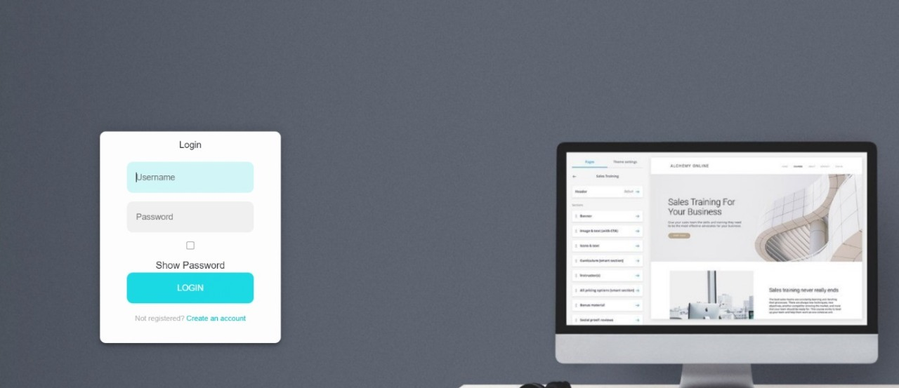

**SIGN-UP PAGE:**

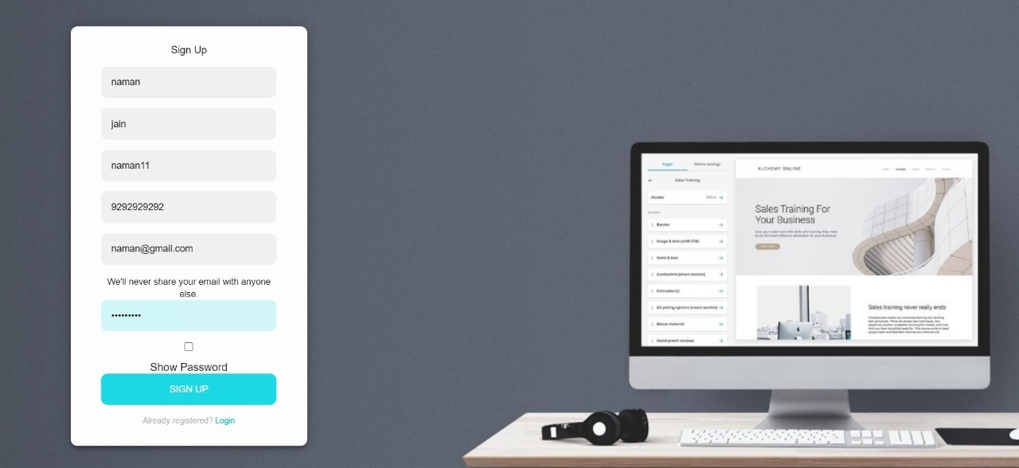

**HOME PAGE:**

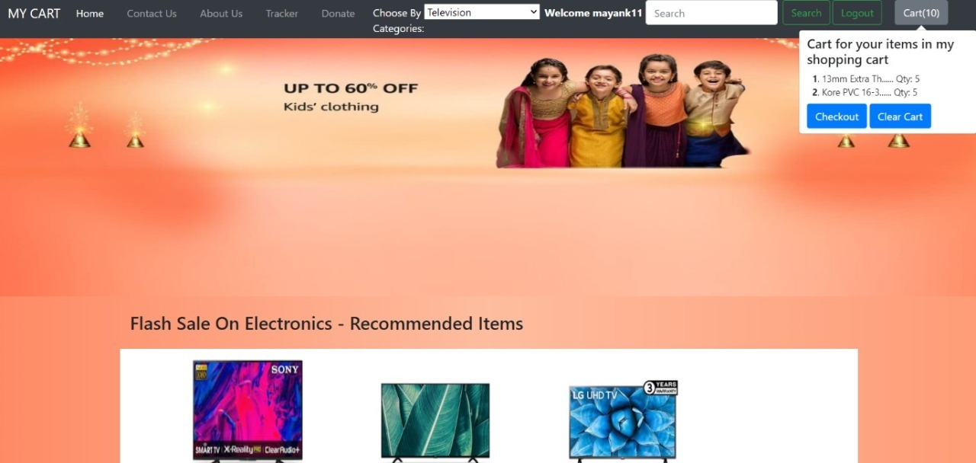

**QUICK VIEW PAGE:**

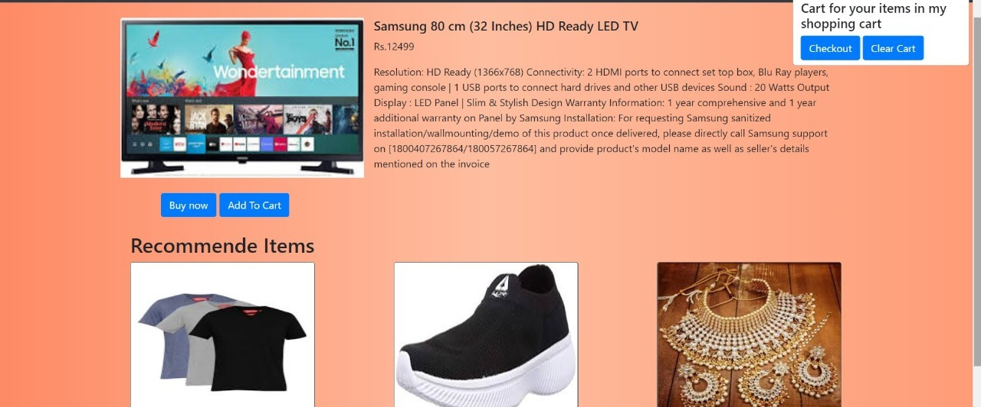

**CHECKOUT PAGE:**

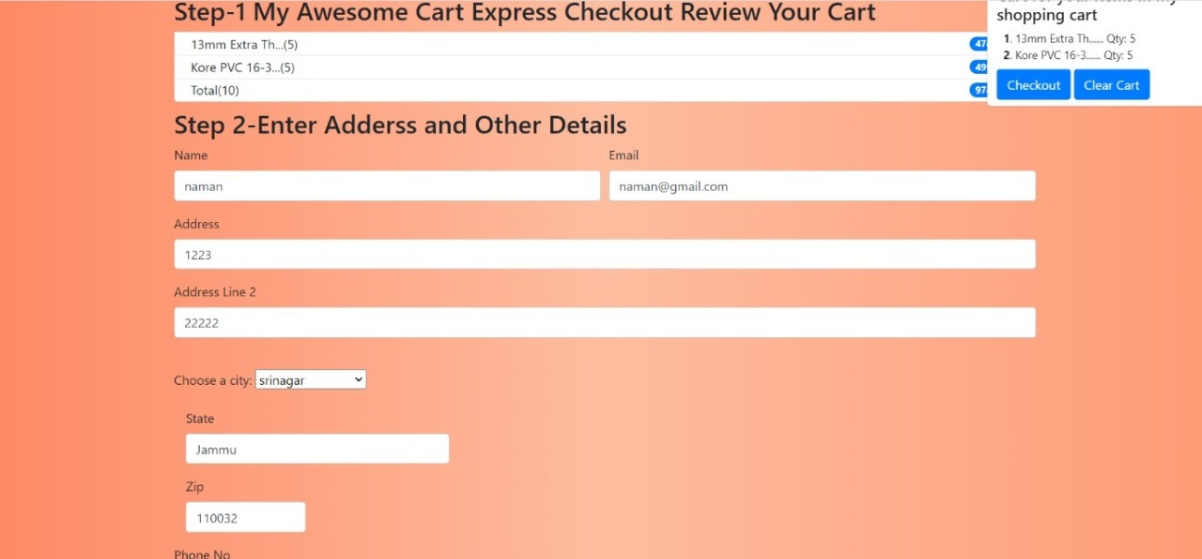

**TRACKER PAGE :**

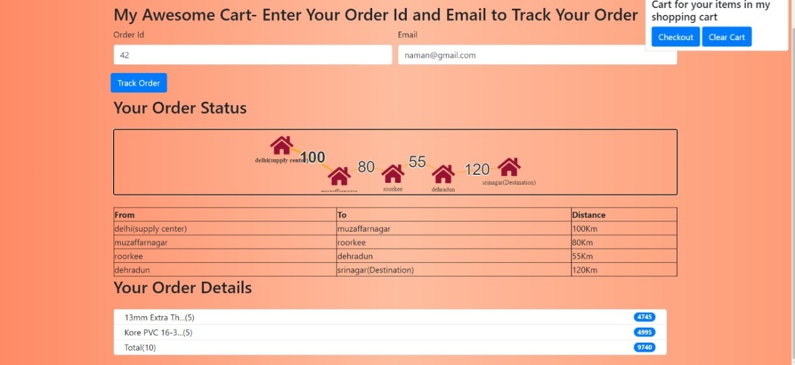

**CHALLENGES FACED**

We faced many challenges during the development of this project and we also enjoyed and learnt many things during this period. At first, we didn’t know about Django, so the first challenge for us was to learn this python framework along with Python, as we were not comfortable with python as well.

Then we learnt some advanced HTML/CSS and JavaScript. We also learnt basic Bootstrap to add some style to our website.

Many times we got stuck in between then we used some online resources for help.

**GITHUB LINK-**

<https://github.com/naman267/mycart>

**BIBLIOGRAPHY**

1. https://www.geeksforgeeks.org/

2. https://www.programiz.com/

3. https://www.tutorialspoint.com/

4. https://www.wikipedia.org/